An Overview of SWFSC’s
Environmental Research Division’s (ERD)
Data Services and Tools

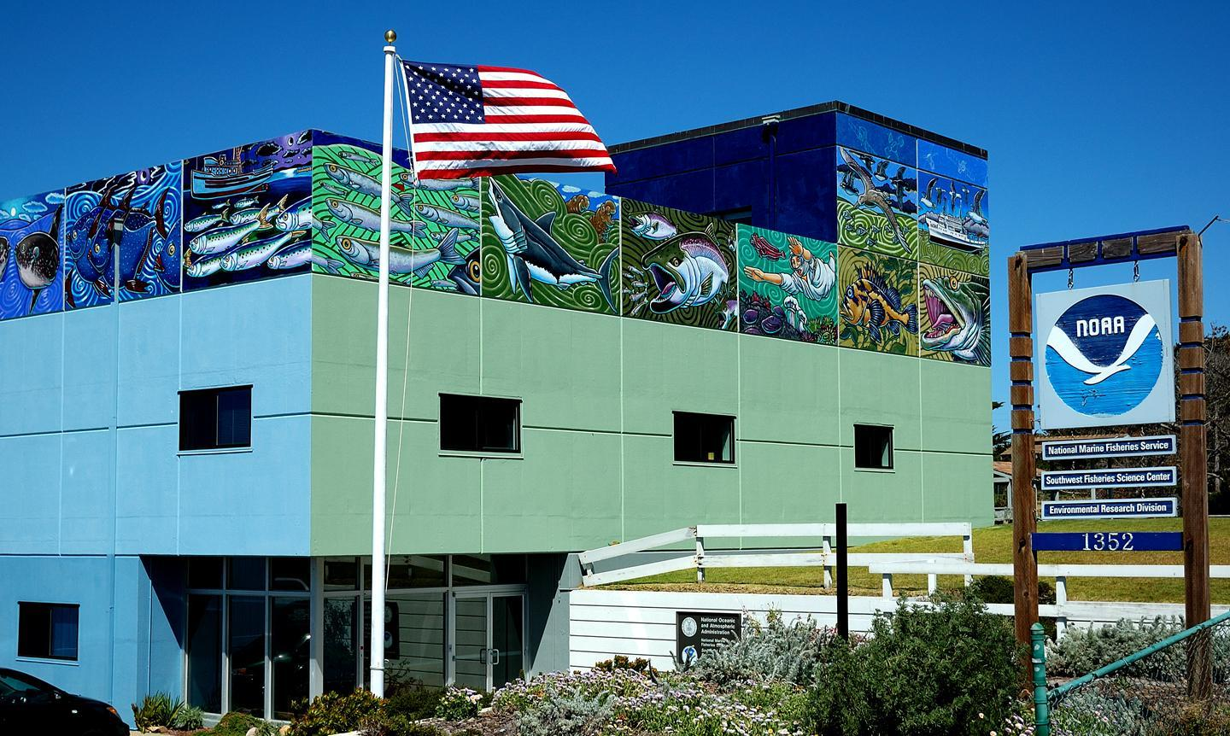
The ERD (formerly PFEG and PFEL) facility, 1995 – 2014

ERD’s data group:

Roy Mendelssohn, Lynn DeWitt, Bob Simons, Dale Robinson & Dave Foley*

*deceased December 8, 2013

Last updated: August 2014

Satellite Data Browsers
West Coast of the U.S. & Mexico:
http://coastwatch.pfel.noaa.gov/coastwatch/CWBrowser.jsp
Global, longitude 0° to 360°:
http://coastwatch.pfel.noaa.gov/coastwatch/CWBrowserWW360.jsp
Global, longitude -180° to 180°:
http://coastwatch.pfel.noaa.gov/coastwatch/CWBrowserWW180.jsp

ERDDAP
http://coastwatch.pfeg.noaa.gov/erddap
http://coastwatch.pfeg.noaa.gov/erddap/griddap

The EDC for ArcGIS, Matlab, R or Excel
http://www.pfeg.noaa.gov/products/EDC/ or
http://www.asascience.com/software/downloads/

Xtract-o-matic routines for Matlab & R
http://coastwatch.pfel.noaa.gov/xtracto/

ERD THREDDS server
http://oceanwatch.pfeg.noaa.gov/thredds/catalog.html

NOAA Satellite Course
http://www.pfel.noaa.gov/events/NOAASatCourses

Questions or Comments?
e-mail cara.wilson@noaa.gov

Table of Contents

Summary of ERD’s tools 4
Overview of ERD Datasets 5
Satellite Data Browsers 6
ERDDAP 11
Environmental Data Connector (EDC) 16
X-tractomatic scripts for Matlab & R 20
Specialized Web pages 22
NOAA Ocean Satellite Courses 23

Summary of ERD’s tools

Tool | Usage | Programs | Pros/Cons
Satellite Data Browsers | Good tool for viewing satellite datasets |  | Not recommended for downloading data. Not all satellite datasets on all the browser, most notable VIIRS and Aquarius salinity datasets are not on it.
ERDDAP | A data server that gives you (or a machine) a simple, consistent way to download subsets of scientific datasets in common file formats and make graphs and maps. ERDDAP was developed at ERD by Bob Simons, but other centers now have their own ERDDAP servers. | Data can be visualized or downloaded in a variety of data and image formats or accessed directly from within tools such as Matlab, R, GrADS and more | Extensive data holdings, not just satellite data (i.e., ARGO floats, NDBC buoy data, CalCOFI data and model output are also on ERDDAP). Allows for viewing datasets, but switching between datasets is easier in the Satellite Data Browser.
EDC | Geographical and temporally subset data and import directly into client software. | ArcGIS, Matlab, R, Excel & stand-alone | Works not just with ERD’s data servers, but can connect to any OPeNDAP, THREDDS,IOOS SOS or ERDDAP server
Xtracto | Three scripts that will extract satellite data either along a user-supplied X-Y-T track, from a user-defined bounding box or from a user-defined polygon | Matlab & R | Only works with a subset of the datasets on ERD’s ERDDAP

Overview of ERD Datasets

The data servers at the Southwest Fisheries Science Center’s Environmental Research Division (ERD) serve over 60 TB of data. The West Coast node of NOAA’s CoastWatch program (coastwatch.noaa.gov) is part of ERD, and the Coastwatch satellite browsers provide access to oceanographic satellite data as part of this program. The CoastWatch browsers provide data over a limited time range, while ERD data services provide data over as long a time period as possible. ERD data services also provide a variety of other environmental data in addition to satellite data. A brief, and incomplete, listing of some the dataset holdings is given below. For a complete listing of all the datasets served by ERD go to the ERDDAP server: http://coastwatch.pfeg.noaa.gov/erddap/

Satellite datasets
Ocean Color: SeaWIFS, MODIS and VIIRS data datasets
SST: AMSR-E, AVHRR, blended products, GOES, GHRSST, MODIS, Pathfinder datasets
Ocean Vector Winds: ASCAT and QuikScat datasets
Altimetry: AVISO SSH datasets
Salinity: Aquarius dataset

For more information about these satellite datasets, see the “Satellite Data Primer”, also produced by ERD. A version can be found at http://www.pfel.noaa.gov/events/workshops/NOAASatCourse2013/CourseInfo.html

In-situ datasets:
ARGO floats
CalCOFI data
California Fish Market Catch Landings
HF Radar data
Underway meteorological data from RVs and NOAA ships
NDBC buoy data
World Ocean Atlas data (2009)

Model data:
SODA (Simple Ocean Data Assimilation)
NAVGEM (FNMOC Global Environmental Model - replaced NOGAPS)
NOGAPS (FNMOC Global Environmental Model)

Satellite Data Browsers

West Coast of the U.S. & Mexico:
http://coastwatch.pfel.noaa.gov/coastwatch/CWBrowser.jsp
Global, (longitude 0° to 360°):
http://coastwatch.pfel.noaa.gov/coastwatch/CWBrowserWW360.jsp
Global, (longitude -180° to 180°):
http://coastwatch.pfel.noaa.gov/coastwatch/CWBrowserWW180.jsp

or google “CoastWatch 360” or “CoastWatch 180”

The West Coast node of NOAA’s CoastWatch program (which has been housed at the ERD since 2003) has developed three primary satellite data browsers. The first browser developed covers the west coast of the US, while the other two browsers are global, and were developed when it was apparent that users of west coast CoastWatch node needed datasets at global resolution. Datasets in the “WW360” browser have longitude in 0° to 360°, and datasets in the “WW180” browser have longitude in -180° to 180°. The WW360 and WW180 browsers have all of the datasets that the west coast browser has, plus a few additional datasets for regions other than the west coast of the U.S. Different datasets have different spatial resolutions and different temporal composite options. Note the “Pacific Ocean” datasets, which have a higher spatial resolution than the “Global” datasets, actually include an area that covers much of the northwestern Atlantic Ocean.

Currently new datasets are not routinely being added to the browsers. Consequently there are a number of significant satellite datasets that are not on the browsers, for example VIIRS chlorophyll data, Aquarius salinity data, and the high resolution (1 km) GHRSST datasets. These datasets are available via THREDDS and ERDDAP (see page 6). The browsers are a good tool for tasks such as:

- browse through the different datasets to see the amount of coverage in one’s area of interest
- easily compare different temporal composting options
- get a quick timeseries for a point
- compare satellite data to buoy data
- overlay vector wind fields
- make a quick animation

Below we describe how to do these tasks. While the data associated with any image can be downloaded from the browser in a variety of data formats (.asc, .kml, .hdf, .mat,
.nc etc), our other tools (ERDDAP, page 11, or the EDC, page 16) are better optimized for downloading chunks of data.

Compare different datasets in a particular region
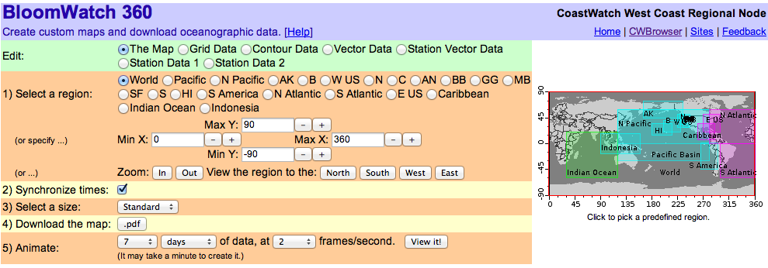
Figure 1. “Map” page of the CoastWatch Browsers.
To choose an area, click the “The Map” button on the Edit field (the green row) at the top of the page (Figure 1). You can select one of the predefined regions, or select your own latitude and longitude limits. If you want the map to span the dateline, make sure you are using the “WW360” browser. Similarly, if you want the map to span the prime meridian, make sure you are using the “WW180” browser. After you have the map displaying your region of interest, click the “Grid Data” button on the Edit field (the green row) at the top of the “Grid Data” page. Select a dataset from the drop-down menu in the first orange row at the top of the page (Figure 2). Datasets are arranged alphabetically. If there is not much color variation on the map you will want to change the palette (orange row #5) minimum and maximum values. By default, chlorophyll is mapped to a log scale, it can be changed to a linear scale if that is preferred. By default, the most recent data available is displayed. To select a different time, choose one in “Select a centered time” (orange row #3). As an exercise look at a daily composite of the following SST (sea-surface temperature) products for your region:
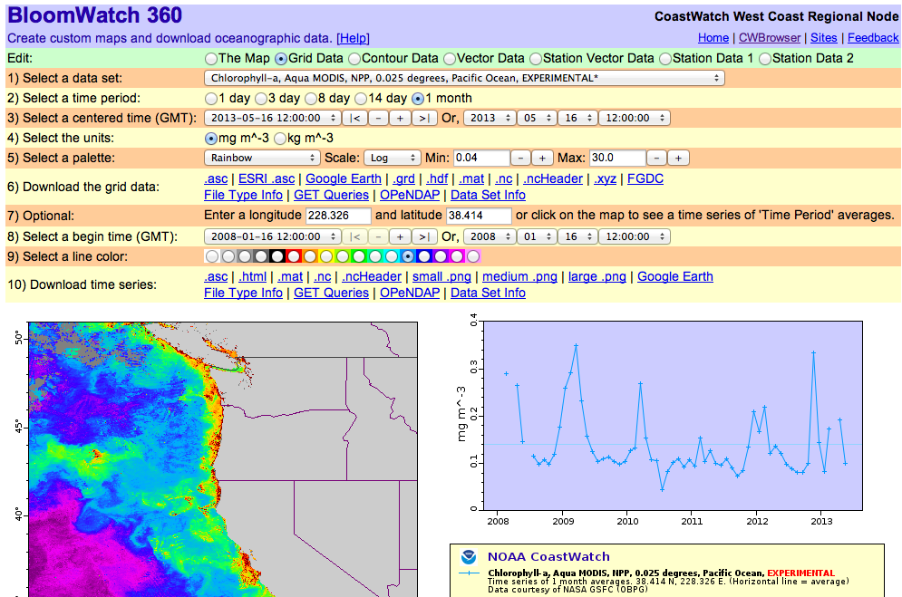
Figure 2. “Grid Data” page of the CoastWatch Browsers, showing a timeseries plot.

- AMSR-E, a microwave measurement that can see through clouds
- MODIS, an IR measurement that can not see through clouds
- GOES, an IR measurement from a geostationary platform, taken every 15 minutes

Also look at each of these products in the various temporal compositing options that are available. This is done by selecting a time period in row 2 (yellow row). The temporal composites are the average data for a given time-period, based on a center time, meaning a 5-day composite for Aug 22 will include data from Aug 20-24.

Near-Real-Time (NRT) data vs. Science Quality data - NRT data is between a few minutes and a few months old. The goal is to make the data available as soon as possible. Science quality data are at least two months old. The extra time is used for additional quality control and validation of the data. Sometimes different processing methods are used for science quality and near-real-time data sets. The browsers have both NRT and science quality data sets. NRT datasets may or may not be labeled as such. Science quality data sets are always labeled "Science Quality".

Viewing a timeseries
Make sure you are on the “Grid data” page (Figure 2) and then click on any point on the map to create a timeseries of the data at that point. The timeseries plot will show up on the right side of the page. The end time of the plot corresponds to the time of the image displayed on the left. The default is to display a month of data. To increase the length of the timeseries displayed, change the beginning data in “Select a begin time” (yellow row #8). To see a timeseries at a different spot simply click on that spot on the map or enter the exact coordinates in “Optional” (orange row #7). Only one timeseries can be viewed at a time. To remove the timeseries click any spot on the timeseries plot.

Comparing satellite data to buoy data
Select any SST product from the “Grid Data” page and make sure the color palette is fully utilized (i.e., the map isn’t entirely blue or red), by changing the palette minimum and maximum values if necessary. Select the “Station Data 1” button on the Edit field (the green line) at the top of the page. Select “SST (NDBC Buoy)” from the drop down menu. The browser will automatically sync the times of the two different datasets (if you don’t want them synched, go the “The Map” page and uncheck “Synchronize times”, see Figure 1). If you have changed the min and/or max of the color palette for the satellite field, you will also have to change the min and/or max of the color palette for the buoy data to get them on the same scale. The buoys will show up as colored boxes
(Figure 3). If they are gray that means there is no data from them for the selected timeperiod. Timeseries of buoy data can also be plotted as described previously.

Overlay vector wind fields
Select the “Vector Data” button on the Edit field (the green row) at the top of the page. Select one of the wind products from the drop-down list. The wind vectors will show up over whatever field is displayed on the map. The browser will automatically sync the times of the two different datasets (if you don’t want them synched, go the “The Map” page and uncheck “Synchronize times”, see Figure 1). To have the map show the wind speed as the colored mapped variable, go to the “Grid Data” page and select the modulus parameter of the wind product whose vectors are displayed.

Add contour lines
Select the “Contour Data” button on the Edit field (the green row) at the top of the page. Select a variable to contour. It does not have to be the same variable mapped out. The contours will show up over whatever field is displayed on the map. The browser will automatically sync the times of the two different datasets (if you don’t want them synched, go the “The Map” page and uncheck “Synchronize times”). The default color of the contours is red, it can be changed in “Select a color” (yellow row #2). The number of contour lines can be adjusted in “Draw lines at” (orange row #3). Specifying one number will set up a constant interval spacing. Entering a list of values will set the contours lines at those specific values.
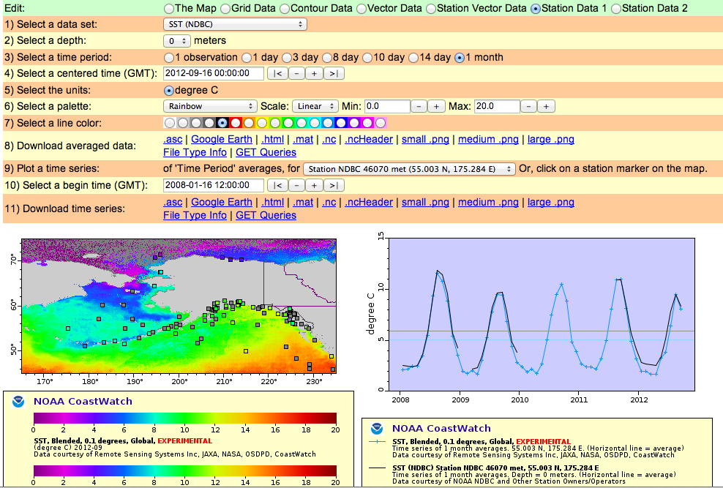
Figure 3. “Station Data” page of the CoastWatch browsers, showing a spatial and temporal comparison between satellite SST data and SST data from NDBC buoys.

Make a quick animation
Select the “The Map” button on the Edit field (the green row) at the top of the page. Select the number of images to animate (orange row #5) and click on “View it!”. This should not be done for a large number of timesteps!

For more help

See the Help link at the top of each CWBrowsers, e.g.,
http://coastwatch.pfeg.noaa.gov/coastwatch/CWBrowserWW180Info.html

ERDDAP

http://coastwatch.pfeg.noaa.gov/erddap or
http://upwell.pfeg.noaa.gov/erddap/griddap

or google “ERDDAP ERD” or “ERDDAP UAF”

ERDDAP stands for the Environmental Research Division’s Data Access Program. ERDDAP is a web application (for humans with browsers) and a web service (with services for computer programs). It was written by Bob Simons to provide a easier access to datasets for both people and machines. ERDDAP:

- Offers a consistent way to get data from a variety of different data sources. In addition to satellite datasets, ERD’s ERDDAP serves other datasets such as ARGO floats, NDBC buoys, CalCOFI data and model output.
- Lets you download data in your preferred data file format (netcdf, csv, ESRIcsv, JSON, ODVtext, mat, text and more)
- Lets you create images in your preferred image file format (png, transparent png, pdf, kml)
- Supports temporal and spatial subsetting
- Is “RESTful”, meaning the URL completely defines the data you want, in the format you want. This is described in more detail on page 13.

ERD hosts two different ERDDAP servers. The “oceanwatch” ERDDAP is the primary data server for the datasets of interest to ERD. The other ERDDAP is part of NOAA’s UAF (Unified Access Framework), an effort to develop a unified access to NOAA’s distributed data, with the initial effort focused on gridded datasets in NOAA. In September 2013 there were 751 datasets on the oceanwatch ERDDAP server and 2,061 on the UAF server. (All of the data on the oceanwatch ERDDAP are also on the UAF ERDDAP).
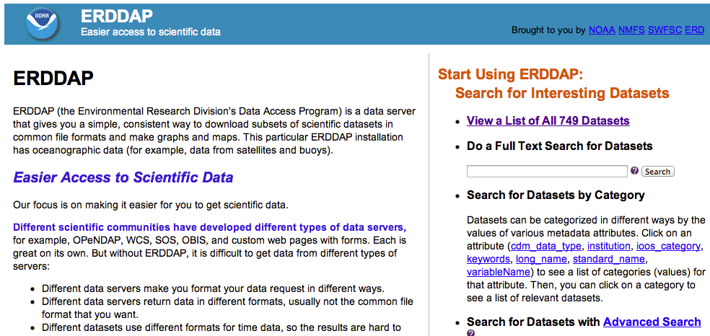
Figure 4. Snapshot of main ERDDAP page. To select a dataset use the search box, or click on “View a list of all… “ to see all the available datasets.

To use ERDDAP:
- Search for a dataset of interest with one of the options on the right side of the ERDDAP home page. For example, enter “SST” in the Search textbox or click on “View a list of...” to see all the available datasets (Figure 4)
- Click on the dataset’s “graph” link (Figure 5) to get a form that helps you create graphs and maps of the data.
- Click on the dataset’s “data” link (Figure 4)to get a form that helps you download a subset of the dataset in the data file format that want.
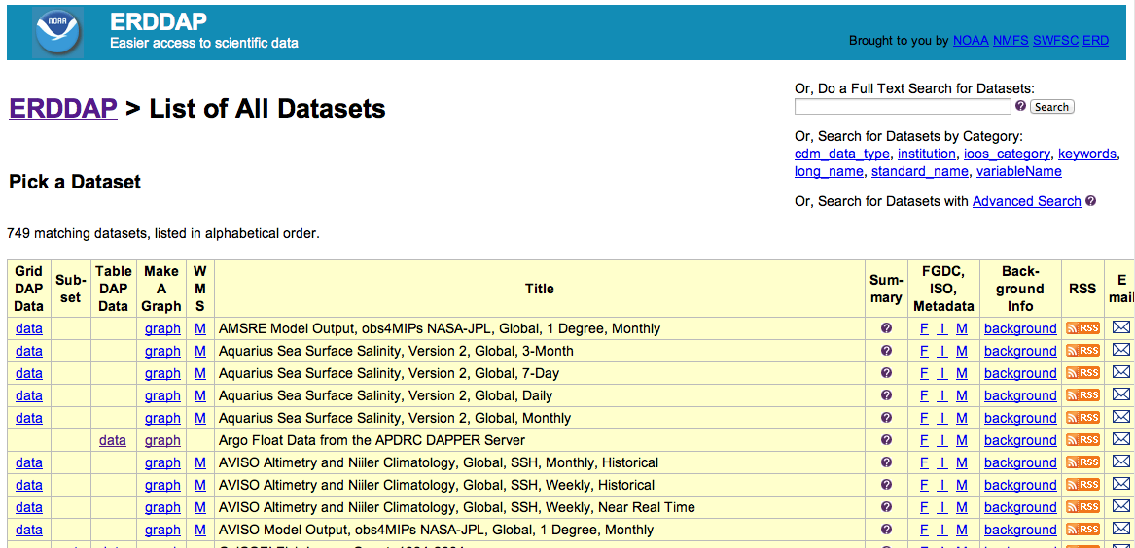
Figure 5. Snapshot of the top of the listing of all datasets on the ERD Oceanwatch ERDDAP server. Clicking “graph” to the left of a dataset will bring up a page to select a portion of that dataset to visualize. Clicking “data” to the left of a dataset will bring up a page to select a portion of that dataset to download.

ERDDAP’s RESTful URLs
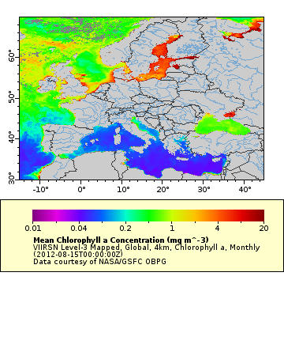
ERDDAP is “RESTful”, meaning the URL completely defines the data you want, in the format you want. The forms on the “graph” and “data” web pages help you create a URL that specifies your entire request. For example, the map on the right was produced by this URL:

http://coastwatch.pfeg.noaa.gov/erddap/griddap/erdVHchlamday.png?chla[(2012-08-15T00:00:00Z)][(70):(30)][(-15):(45)]&.draw=surface&
.vars=longitude|latitude|chla&.colorBar=||Log|.01|20|

The parts of the URL are:
- The chla variable in the erdVHchlamday dataset has [time][latitude][longitude] dimensions. For each dimension, you can specify a single value, e.g., [(value)], or a range of values, e.g., [(start):(stop)].
- Since this dataset is monthly data, [(2012-08-15T00:00:00Z)] indicates that you want data from August 2012.
- [(70):(30)] indicates that you want data from latitude 30°N to 70°N. The numbers are specified high to low because this dataset (VIIRS) stores latitude values high to low. That is unusual, most datasets store latitude values low to high.
- [(-15):(45)] indicates that you want data from longitude -15° to 45°.
- The & options at the end specify how the graph/map should be created.

By far the easiest way to generate a URL to request a graph or a subset of data is to use the “graph” and “data” links in ERDDAP (Figure 5). But once you have one URL for a dataset, it is easy to make small changes to request related graphs or related subsets of data. For example, in the URL above

- Changing png to mat will download the data in a Matlab formatted file.
- Changing png to nc will download the data in a netCDF file.
- Changing png to graph will generate a webpage where the image can be modified.
- Changing png to html will generate a webpage where a chunk of the data can be downloaded.
- Changing png to csv will download data for use in a spreadsheet application such as Excel
- Changing 2012-08-15T00:00:00Z to last will generate the image with the most recent data.
- Changing erdVHchlamday to erdVHchla1day or erdVHchla8day will generate the image with 1-day or 8-day compositing.
- For more data and image output options see
http://coastwatch.pfeg.noaa.gov/erddap/griddap/documentation.html#fileType
http://coastwatch.pfeg.noaa.gov/erddap/griddap/documentation.html#imageFileTypes
Matlab
You can directly import any data on ERDDAP into Matlab with one call by using the Matlab function “urlwrite” For example the command:

load(urlwrite('http://coastwatch.pfeg.noaa.gov/erddap/griddap/erdVHchla8day.mat?chla[(2013-01-01T00:00:00Z):1:(2013-07-30T00:00:00Z)][(40):1:(20)][(-150):1:(-130)]', 'test.mat'));

will bring the 8-day VIIRS chlorophyll from Jan 1 2013 through Jun 30 2013, between 20°-40°N, and 130°-150°W directly into Matlab. The data will be in a Matlab structure. The structure's name will be the datasetID (here erdVHchla8day). The structure's internal variables will have the same names as in ERDDAP, (for example, use fieldnames(erdVHchla8day)). The numbers are specified high to low because this dataset (VIIRS) stores latitude values high to low. That is unusual, most datasets store latitude values low to high.

In Matlab, the “nctoolbox” simplifies the use of OPeNDAP URLs: http://code.google.com/p/nctoolbox/

R
In R, data served by ERDDAP can in the general case be accessed using the “download.file” command, as in the case above:

chla<-download.file('http://coastwatch.pfeg.noaa.gov/erddap/griddap/erdVHchla8day.nc?chla[(2013-01-01T00:00:00Z):1:(2013-07-30T00:00:00Z)][(40):1:(20)][(-150):1:(-130)]', destfile="chla.nc",mode='wb')

will download the netCDF file “chla.nc” which can then be opened in R using the package “ncdf4”. For Mac and Linux users of R (where ncdf4 supports the OPenDAP protocal the commands

library(ncdf4)
chlaFile<-nc_open('http://coastwatch.pfeg.noaa.gov/erddap/griddap/erdVHchla8day')
will directly open the ERDDAP dataset in R. The disadvantage is that the rest of the subsetting must be done in index space rather than coordinate space. Similarly, especially for tabular data, returned as a “.csv” file, the “read.csv” command will access the data directly, for example:

seaTemp<-read.csv('http://coastwatch.pfeg.noaa.gov/erddap/tabledap/fsuNoaaShipWTED.csv?longitude,latitude,seaTemperature&time>=2013-08-23T00:00:00Z&time<=2013-08-30T00:00:00Z',skip=2,sep=",")

will directly access a short period of underway sea temperature data from the NOAA vessel Bell Shimada.

Other tools:
In addition to their use in Matlab and R, ERDDAP URL’s can be used to directly access data in any application, programming language or scripting language that can send an URL and receive a file (such as Python, Java, php, JavaScript, shell scripts using “curl” or “wget”), as well as from OPeNDAP-enabled applications clients such as R, GrADS, Ferret, and IDL. Many programming and scripting languages such as Java, python, php, and JavaScript can manipulate ERDDAP URL’s to import data for research or modeling or for use in dynamic web pages. For some examples of this see page 22.

More information about how ERDDAP works can be found at:
http://oceanview.pfeg.noaa.gov/erddap_tutorial/
http://coastwatch.pfeg.noaa.gov/erddap/information.html

Environmental Data Connector (EDC)

http://www.pfeg.noaa.gov/products/EDC/ or
http://www.asascience.com/software/downloads/
or google EDC ERD

The EDC is a Java-based Graphical User Interface (GUI) that allows for easy access to distributed data from directly within ArcGIS, Matlab, R and Excel (Windows only). Using web services the EDC can access data served by OPeNDAP, THREDDS, ERDDAP, IOOS SOS and also local files. The EDC allows the user to search and graphically select the temporal and spatial subset of the data desired, and then the selected subset of the data is automatically brought into the software application. The EDC was developed by Applied Science Associates (ASA) under contract funding from ERD. The first version came out in 2008. Since then there have been a number of revisions made to the EDC. The most recent version (released July 2013) can be used from within ArcGIS (updated to work with version 10.2), as well as from within Matlab, R, Excel (Windows only) and as a standalone Java application. There is a single install file that installs all versions of the EDC (Java is required to run the installer). Installation instructions as well as an EDC User’s Manual come as part of the installation files.

EDC-GUI
The EDC GUI provides a common interface across versions. There are two windows that will come up with the EDC. The first window (Figure 6) provides a dialogue to provide the source of the data, as well as to select the desired dataset. The data source is chosen in the top portion of the window. Valid data sources include URLs of THREDDS data catalogs, URLs of non-THREDDS OPeNDAP servers (or local netCDF files), URLs of SOS servers, or URLs of ERDDAP servers. The drop-down menus list some common sources for oceanographic and atmospheric data. You may select one of the catalogs or datasets in the drop-down menus or manually type in a different URL. The ‘Catalog URL’ connects to THREDDS dataset catalogs, while the ‘Direct Access URL’ connects to OPeNDAP servers. Once you have selected a catalog, dataset, or service, click the ‘Connect’ button to connect to that server. Once the EDC is connected to the server, the datasets available on that server will be displayed on the left, and can be browsed similarly to the dialog in a normal “Open” command (that is clicking on a folder will open up the next level in the file hierarchy, clicking on a dataset will select it). When connected to an ERDDAP server, datasets are searchable over a variety of criteria in order to narrow down the choice of datasets. When a particular dataset has been selected, the metadata about that dataset will be displayed in the right-hand window, including spatial and temporal bounds if available from the service. After a dataset has been selected click on the “Subset & Process” button. Another window will be launched (Figure 7).
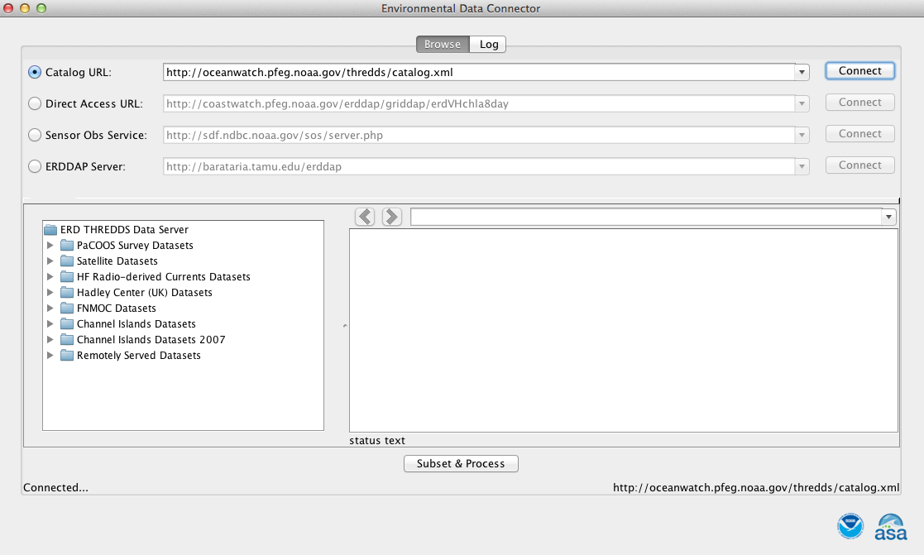 Figure 6. The EDC window to select the source of data and the particular dataset. A list of datasets at the chosen site will show up on the left. Information about a chosen dataset will show up on the right.
Grab the globe with the mouse to move it around to your region of interest. You can select an area by drawing on the map with the mouse by clicking the “Select by BBOX”. You can also enter the exact coordinates of your box. You also must select the variable in the upper right-hand corner. Click on the “Process” button to extract the desired subset of data. After the data has been extracted, the EDC window will close and you will revert back to the software platform you started from.

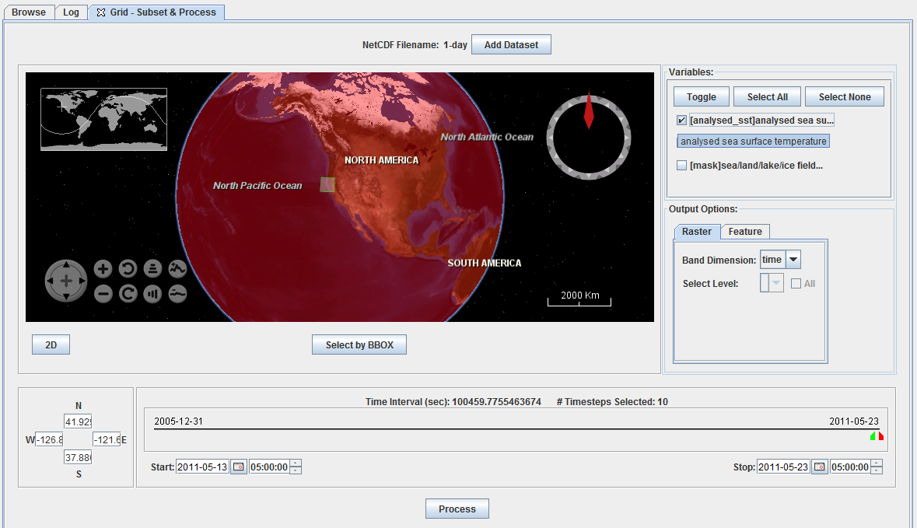
Figure 7. The spatial and temporal subsetting window of the EDC.
The current release of the EDC cannot download data which span either the prime meridian (0° longitude) or the international dateline (180° longitude), depending on the bounds of the original dataset. In order to get the entire region of the data, you should download the data in two pieces with one west of the bounding longitude and the other east of the bounding longitude. Then merge the data in your software application.

EDC-ArcGIS
To launch the EDC from AcGISr (after it has been installed) click on the “EDC” icon on the top of the ArcGIS menu bar. Follow the directions under the EDC-GUI (page 16). Once the download is complete, the EDC will close. The downloaded netCDF file is then converted to two types of files, an ArcGIS raster for each time step and a raster catalog of all the data using ArcGIS’s conversion tools. Be patient while ArcGIS converts the file. At this point, take a note of the date range and time steps you have selected as it can be difficult to find this information after it is downloaded. This can often be a lengthy step and there is no progress bar to show that ArcMap is still working on the conversion. The resulting ArcGIS layer consists of a raster catalog along with the first raster of the data set which displays a legend for the full dataset. The data dimension used as the band dimension is specified in the ‘Output Options’ window of the EDC. This band dimension is usually time, but can be another dimension (such as depth or height), if that dimension is available. Raster catalog files cannot be manipulated using the spatial analyst tool box (e.g. raster calculator and map algebra), and instead you should add all of the desired raster files from the EDC download directory (by default this is c:\EDC\). If the dataset contains more than 3 dimensions, then you must select the value of the 4th dimension in the ‘Select Level’ menu. For example, if the dataset has dimensions of ‘latitude’, ‘longitude’, ‘altitude’, and ‘time’, and you select ‘time’ as the band dimension, then you would have to pick the altitude level of the data. Some datasets might have a 4th dimension containing only one value (e.g. – 0 meter altitude for sea level data).

EDC-Matlab
To launch the EDC from Matlab (after it has been installed) type:

> satdata=edc_matlab
at the command line. The call is case sensitive. Use of the GUI is the same as described previously (page 16). Once the data has been downloaded locally by the EDC, Matlab opens it up and puts it into a Matlab structure type called “satdata” (or whatever variable name was used in the command line call above) with fields for each variable.

EDC-R
After installing the EDC on your machine, and checking to install the version with R, you will still need to install two libraries before using the EDC, ncd4 and EDCR, by typing at the R prompt:

> library(ncdf4)
> library(EDCR)

Then to launch the EDC from R type:

> satdata <-EDC.get(1)
at the command line. The call is case sensitive. Use of the GUI is the same as described previously (page 16). After the data has been extracted off the server, it will exist in R in a variable called “satdata”, or whatever variable name was used in the command line call above. To see the structure of the download, issue the command:

> str(satdata)

EDC-Excel
The EDC for Excel only works with Windows versions of Excel. It can not import gridded data (i.e. satellite data) that THREDDS or GRIDDAP (ERDDAP) returns, but it can import tabular data from a SOS (Sensor Observation Service) or from TABLEDAP (ERDDAP). To launch the EDC from Excel (after it has been installed) click on the “ASA” tab at the far right of the Excel Menu bar (Figure 8). An icon will show up on the top left-hand part of the window that says “Launch EDC”. Clicking on that will launch the EDC GUI described previously. As already mentioned, it will only import data from SOS or ERDDAP servers. After selecting the data you want, the EDC will process the extraction and download the data, then a window will appear saying “Microsoft Excel is waiting for another application to complete an OLE operation”, click “OK” and your data will appear in your Excel spreadsheet, with the fields labeled in the top row.
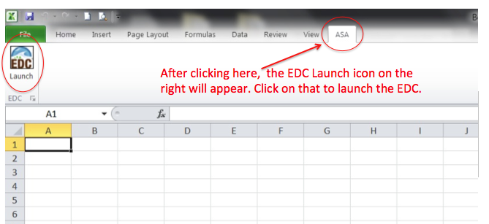Figure 8. Screenshot of an Excel Window set-up to launch the EDC.

X-tractomatic scripts for Matlab & R

http://coastwatch.pfel.noaa.gov/xtracto/
or google Xtracto (with an “X”, not an “E”)

These scripts were written by Dave Foley in response to a need from the tagging community for an easy mechanism to match up moving x-y-t points to satellite data. The original scripts were for Matlab, and Cindy Bessey and Dave Foley created R versions of the scripts. In August 2013 Roy Mendelssohn converted the scripts to work with datasets on ERD’s ERDDAP server. Earlier versions, with “bdap” in the name, work with datasets on the CoastWatch server at ERD. These earlier versions are deprecated because they use a service that is no longer being actively maintained, and may in fact be stopped. Because of this, and also since the ERDDAP server has a more extensive list of datasets, the “erddap” scripts should be used in place of any previous scripts. The most current version of the scripts are on the xtracto website listed above. The R scripts require the package ncdf4, the Windows version of which is not available through CRAN because of some quirks in CRAN policy. The Windows version of ncdf4 can be obtained at http://cirrus.ucsd.edu/~pierce/ncdf/.

xtracto
The xtracto script is a function that extracts satellite values (and the average and standard deviation) from user-supplied vectors containing longitude (xpos), latitude (ypos) and time (tpos). The desired dataset is specified by the data ID code (dtype), which are listed within the xtracto script. The code can be input as a numbered ID code, or by a text string. The final two variables needed for input specify the search “radius”, xrad, and yrad, which define the box (not a circle) around the point that will be searched for all available satellite values. Xrad and yrad can be input as a single number (in decimal degrees) or as a vector, which can be useful if the uncertainty of an animal’s position is variable within a dataset.
For example the R call:
extract<-xtracto(xpos=230, ypos=40, tpos='2006-01-15', dtype='41', xlen=.5, ylen=.5)

will extract seawifs productivity data at 40°N, 130°W for 2006-01-15, with a “radius” of .5° in each direction.

For Matlab, the equivalent call would be:
extract=xtracto(230, 40, datenum('2006-01-15'), ‘41', .5, .5)

xtracto_3D
The xtracto_3D script is a function that extracts a 3-dimensional subset of the data. The first three input variables, xpos, ypos, and tpos, are two dimensional arrays which contain the minimum and maximum value of longitude, latitude and time. The fourth variable, dtype, specifies the desired satellite dataset, using the same ID system as for Matlab, and which is listed within the script.

For example, the following R code:
xpos<-c(-130,-120)
ypos<-c(36,33)
tpos<-c('2013-07-15','2013-07-15')
extract<-xtracto_3D(xpos=xpos,ypos=ypos,tpos=tpos,dtype='erdVHchlamday')

will extract VIIRS chlorophyll data from longitudes (130°-120°W), latitudes (36°-33°N), at 2013-07-15. The equivalent Matlab code is:
xpos=[-130 -120];
ypos=[36 33];
tpos=[datenum('2013-07-15') datenum('2013-07-15') ];
extract=xtracto_3D(xpos,ypos,tpos, 'erdVHchlamday');

The numbers are specified high to low because this dataset (VIIRS) stores latitude values high to low. That is unusual, most datasets store latitude values low to high.
A separate call is used for each desired extract. These scripts only access data from ERD’s data servers. The recommended practice is that these functions are called without modification within a user defined script (for example get_data.m or get_data.R) that specify the required inputs to the function, and that any user modifications to the scripts be done on a copy of the original file.
There are scripts for Matlab (with an “.m” extension) and scripts for R (with an “.r” extension). Don’t get your m’s and r’s mixed up!
Changes from the previous versions of xtractomatic
Users of the original “bdap” xtractomatic scripts should be aware that there are some differences between the ERDDAP scripts and the earlier “bdap” scripts. First, don't assume that the number of the dataset is the same in the new script. Mostly they are, but do double-check by looking at the code.
Not all datasets on the ERDDAP server are on a (0, 360) longitude grid, and not all of the datasets are on a (-90,90) latitude grid. VIIRS data for instance are on a (90,-90) grid. The program will take care of a request in the argument that runs from 30:50 in latitude, but will return the data as it is on the server, that is from 50 to 30. The coordinate information is returned with the data, so always use this for the coordinates of the output of your request, not the request itself.
The information returned from the functions has changed some, the comments at the top of the functions provide the updated information.
In the R scripts, there is now an optional argument "quiet", with default value "quiet=TRUE". If you pass "quiet=FALSE" you can see the details of the ERDDAP URL calls, which can be helpful for debugging purposes if you find a problem.

Specialized Web pages
ERD hosts a number of specialized webpages for various projects and organizations. These all involve tailoring the display and manipulation of data from ERDDAP servers, and highlight the power and utility of the web-based dataservices that ERD has developed. These pages have all been written and maintained by Lynn DeWitt:

SESAME (Salmon Ecosystem Simulation and Management Evaluation)
http://sesame.noaa.gov/
RAFT (River Assessment for Forecasting Temperatures)
http://oceanview.pfeg.noaa.gov/RAFT/
San Francisco Bay Real-Time Stations and Environmental Data
http://oceanview.pfeg.noaa.gov/SFBay/
http://oceanview.pfeg.noaa.gov/explore/tablet (tablet version)
Global Tagging of Pacific Predators
http://oceanview.pfeg.noaa.gov/GTOPPnew
OceanWatch (North Pacific Demonstration Project)
http://oceanwatch.pfeg.noaa.gov
OSCURS (Ocean Surface Current Simulator)
http://las.pfeg.noaa.gov/oscurs/

NOAA Ocean Satellite Courses
Since 2006 ERD has been conducting annual 3-day short courses in oceanographic satellite data. These courses are geared towards National Marine Fisheries Service and National Ocean Service scientists, but are also open to non-NOAA participants if space permits. Through the 2013 course, over 170 people have taken this course, with participants from each of the 6 fisheries science centers, 10 of the 14 marine sanctuaries, as well as participants from other government agencies such as the US Coast Guard, US Geological Survey and the US Fish and Wildlife Service.
The course consists of both lectures and labs. The lectures cover basic information about the various environmental satellite datasets available – ocean color, sea surface temperature, sea surface height, ocean surface vector winds and salinity. The laboratories, the remainder of the course, are spent in a computer class room (each participant has their own computer) so participants can learn where and how to access relevant satellite data from the Internet, focusing on the tools presented in this document. The objective is to show participants how to import satellite data into the platform that is most efficient and appropriate for their needs. Therefore we discuss a variety of different software during the course. We generally focus on ArcGIS, Matlab and R because those are the software packages that have been used the most by participants in our previous courses.
Participants are expected to come to the course with a specific project to work on during the lab component. For example, if their project is to merge tagged animal tracks with satellite data, they should bring the track data with them. This expectation emphasizes that this is very much a “hands on” workshop. Additionally, we find that participants get more out of the workshop if they have specific questions or projects to work on during it. We are however, flexible about this expectation, and we generally won’t turn away eager participants without a specific project.
There is no fee associated with the course, but participants are usually responsible for all their travel costs, although we did have funding in 2006 and in 2013 to cover participants’ travel costs. We usually hold the classes at Oregon State University (OSU) in Corvallis, OR where there is a computer classroom equipped with all the software that we need. The course is usually held the last week in March, when OSU is on spring break.
To be notified about future courses, send an email to cara.wilson@noaa.gov, or sign-up via the online link at http://www.pfel.noaa.gov/events/NOAASatCourses/
Presentations from the 2013 course can be found at: http://www.pfel.noaa.gov/events/workshops/NOAASatCourse2013/CourseInfo.html

